**PYTHON VIRTUAL ENVIRONMENT ON VAGRANT SERVER**

**CORRECTING ERRORS**

IN ORDER TO ACHIEVE THIS GOAL, WE HAVE TO RUN ON GIT BASH, ONCE WE’VE ENTERED TO OUR PROJECT FOLDER AND WE’VE RUN ***vagrant up*** AND THEN ***vagrant ssh,*** WE MUST RUN THIS COMMAND: ***mkvirtualenv “env_name” –python=python3***

FIRST ABLE IF NEXT ERROR APPEARS WHILE TRYING TO RUN ***mkvirtualenv***:

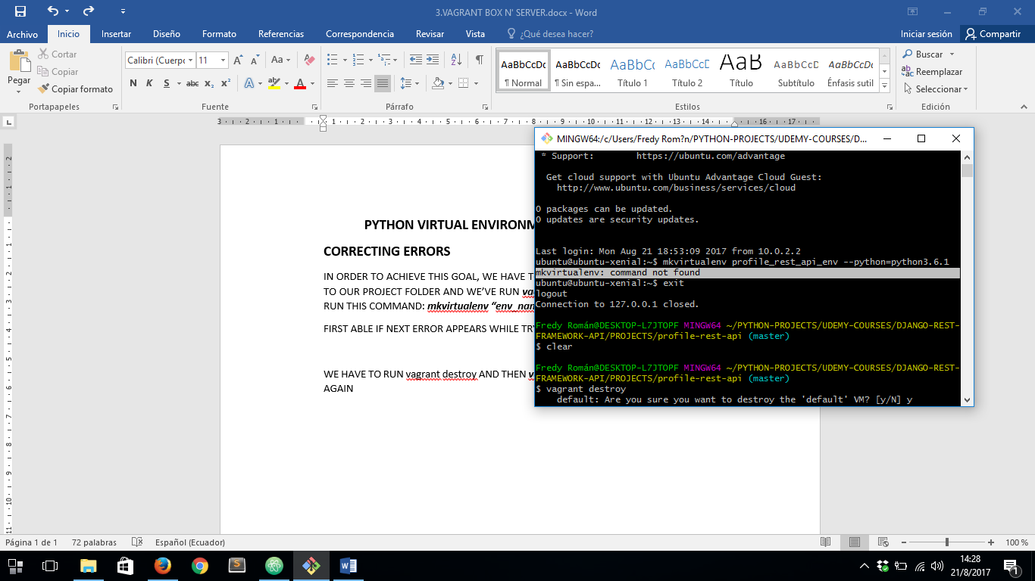

WE HAVE TO RUN ***vagrant destroy*** AND THEN ***vagrant up*** TO RE-INSTALL ALL THE PACKAGES AGAIN.

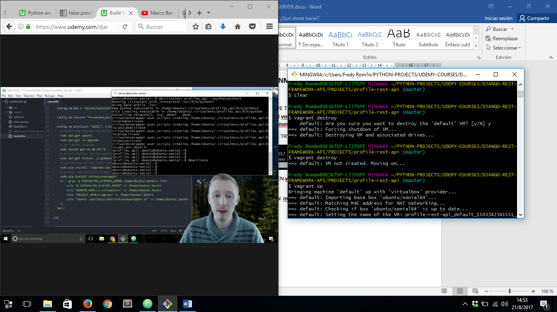

SO NOW WE CAN RUN ***vagrant ssh*** THEN ***mkvirtualenv “env_name” –python=python3*** WITH NO PROBLEM

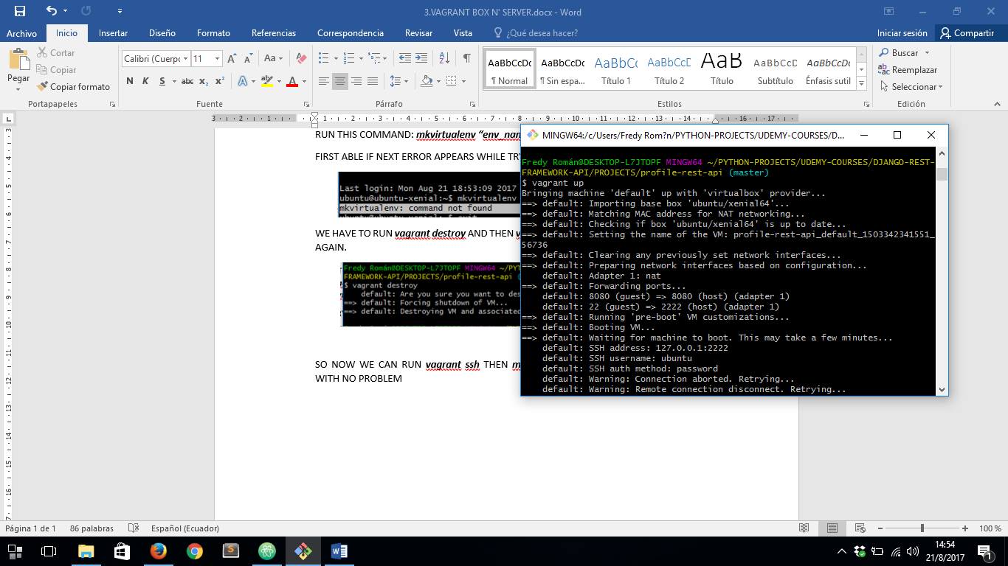

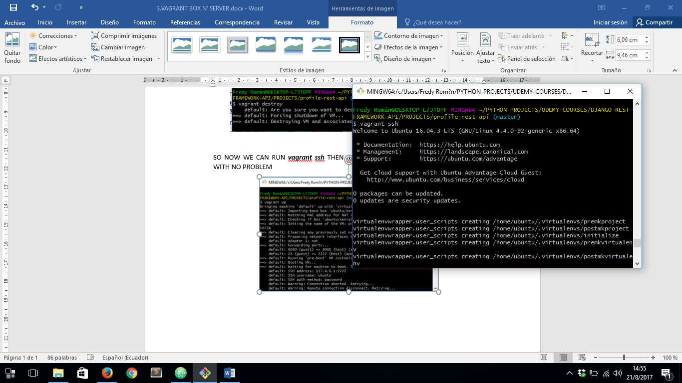

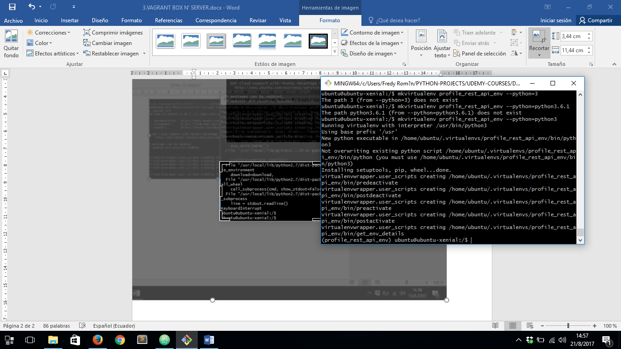

SO LET´S TAKE A LOOK IN THIS LINE:

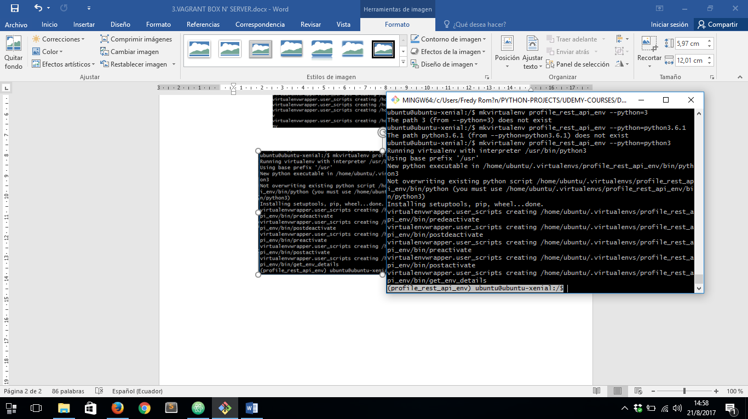

THAT IS THE NAME OF OUR ENVIRONMENT

TO DEACTIVATE THE VIRTUAL ENVIRONMENT WE RUN: ***deactivate***

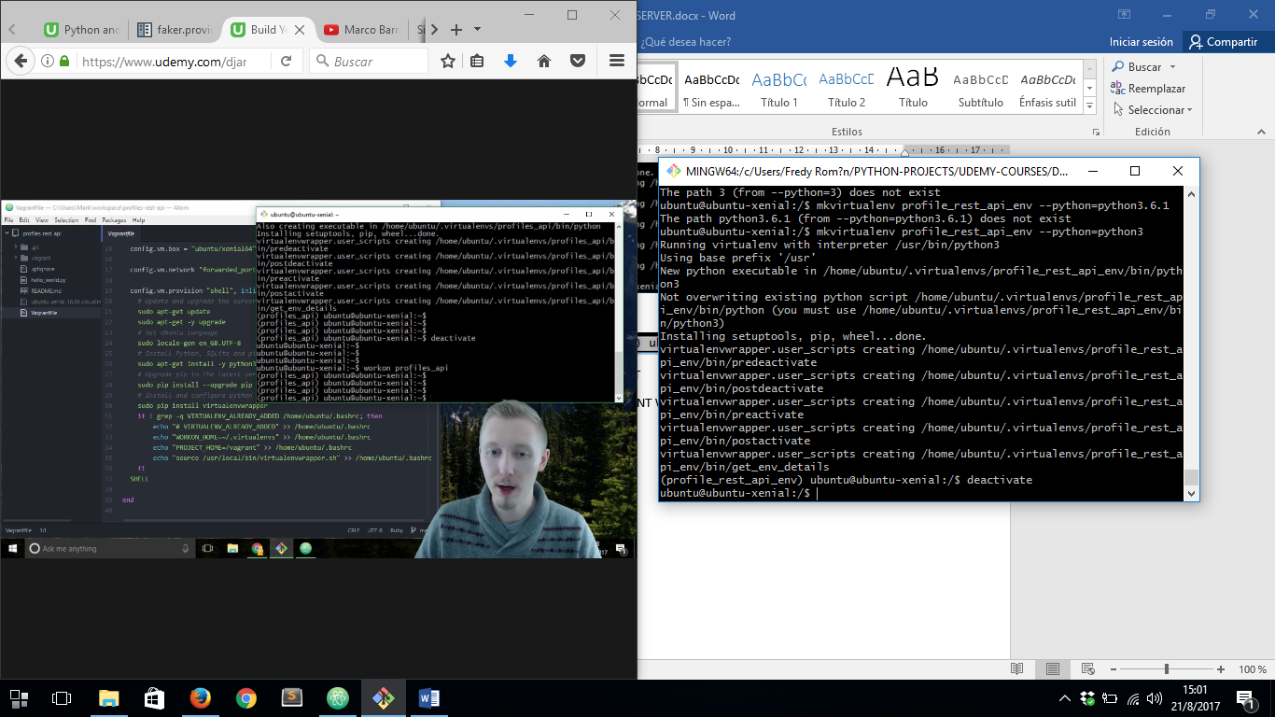

AND FINALLY TO USE OUR ENVIRONMENT AGAIN WE RUN: ***workon “env_name”***

